**Screenshots of task performed**

Creating Procedure for high salary employees above 80,000

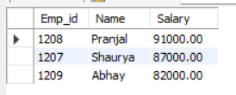

Creating Function to calculate annual salary from monthly salary

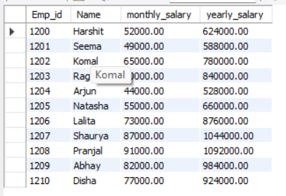

Parameters and conditional logic

